1 Introduction

1.1 Overview

**The book cover is a marketing tool. Its function is to get people to look at the blurbs or the back cover synopsis, not to tell a story. If the author has a following, or the book is part of the series, the cover helps to define the brand.**

1.2 purpose

**The purpose of a book cover is to convey the theme or purpose of your story in a distinctive manner. But, this does not mean that your cover needs to scream your entire story in flashy fonts** and eloquent imagery.

2. Problem definition & Design Thinking

2.1 Empathy map

.

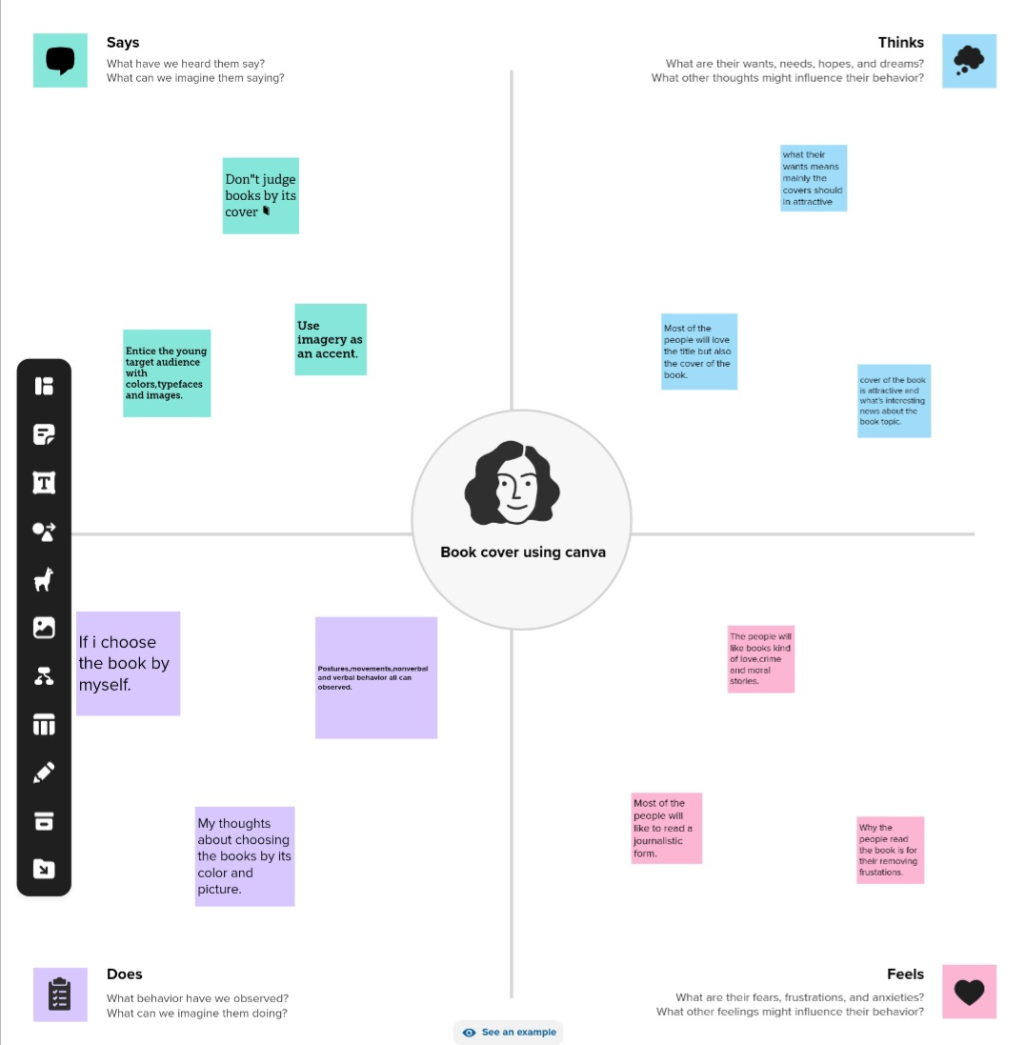

2.2 .IDEATION & BRAINSTORMING MAP

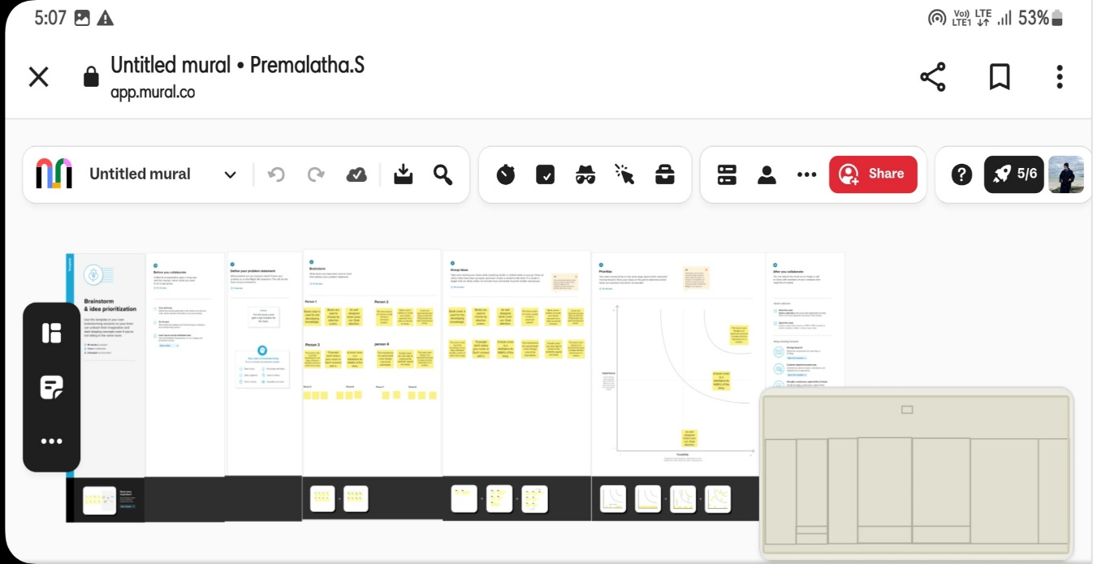

3. RESULT



4. ADVANTAGES AND DISADVANTAGES

Advantage :

Book covers play a crucial role in book publishing, as they are often the first point of contact between the reader and the book. A cover has the power to communicate the book's genre, tone, and theme, as well as to pique the reader's interest.

Disadvantages :

Too many things on the cover become too hard to understand. It is easy to lose structure, hierarchy, and cover your best design elements with too many things.

5. Application

I have used canva application and mural application.

6.Conclusion

We have created book cover with the help of canva.

7.Future scope

We were planning to join the graphic designing course.